1.

A) The board was divided into two regions. Top section ST-link debugger and programmer and the bottom section was actual development board.

CN11 and CN12 jumper pins are actually dummy jumper this jumper can be used for other purposes in future

CN2 are used to connect programmer and debugging section together with development section. In need we can remove the jumper to use the programmer for other ST microcontroller for other purposes through SWD(CN4) male jumper set.

JP1 are used to limit the USB current to 100 mA if the JP1 is open the maximum current through the USB will be 300 mA

The tri-color Led used to indicate the board was powered with RED color, when board id successfully programmed with GREEN color and when there is a communication failure with ORANGE color

The female pin in development section are for Arduino shield which perfectly fits all shield of Arduino UNO

The other male pin is called as ST MARFO pins which can be used to utilize the remaining pin on the 64-pin microcontroller.

We a reset push button in black color and user configurable button that is connected to the PC 13 and a LED that is connected to pin D 13 just as Arduino UNO

We can power the board using mini USB pin in programmer and debugging section or with E5V or 5V pin in development board while we are powering with external power supply

U5V and E5V jumper is used to change the power supply mode. When the U5V was connected it draws power form mini USB port and when E5V is connected it allows to draw current from E5V and 5V pin in development board section

IDD jumper pin is used to measurement how much current was drawn by the microcontroller in use with an external ammeter in series to two pins

C)

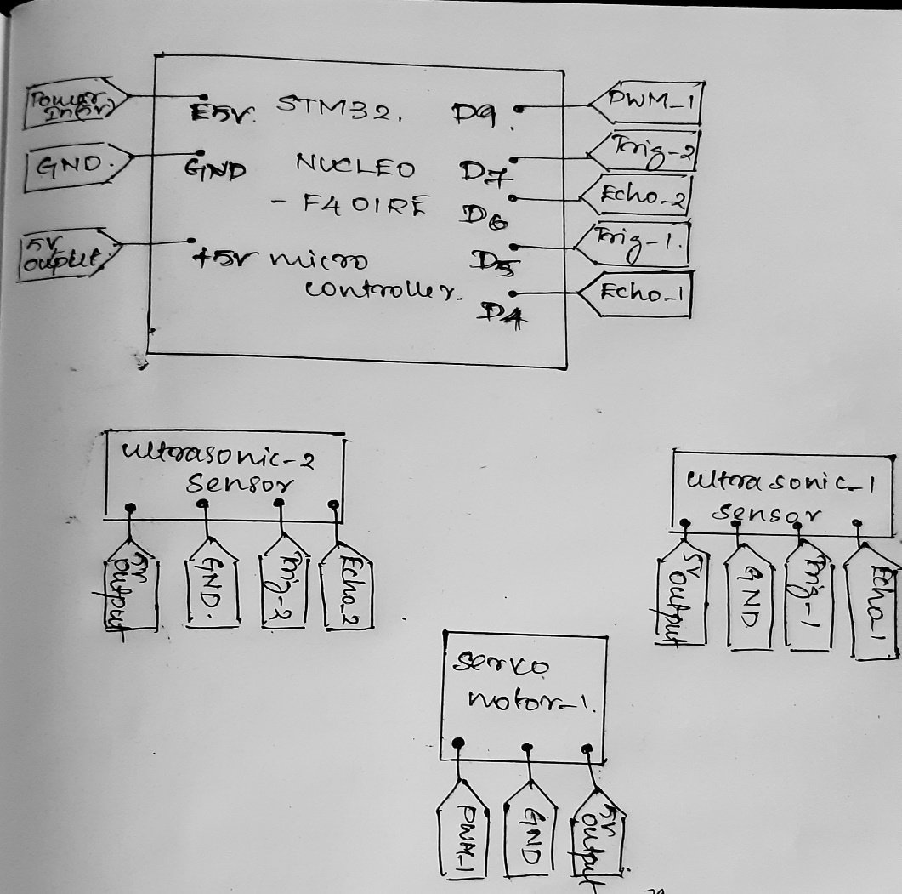

Figure 1 Pin Diagram

ROS:

ROS isn't an operating system however a meta working device meaning, that it assumes there may be an underlying working gadget that will assist it in sporting out its tasks.

ROS depends on the underlying Operating System. ROS demands a whole lot of capability from the running machine. On top of that ROS must be freely available to a large populace, otherwise, a big population won't be able to access it. Much of the recognition of ROS is because of its open nature and smooth availability to the mass population. It additionally needs an operating system that is open source so the working system and ROS may be modified as in step with the necessities of application.

Proprietary Operating Systems consisting of Windows 10 and Mac OS X may also placed positive limitations on how we can use them. This may also cause pressure within the development technique, in order to no longer be perfect for an enterprise-fashionable like ROS. Hence, most humans prefer to run ROS on Linux mainly Debian and Ubuntu when you consider that ROS has superb support with Debian based totally working systems in particular Ubuntu. That doesn’t suggest that ROS can’t be run with Mac OS X or Windows 10 for that remember. But the guide is restricted and those might also locate themselves in a tough state of affairs with little help from the network.

There is near proximity among ROS and OS, so much so that it becomes almost necessary to recognize more approximately the working machine that allows you to paintings with ROS. Using Linux as a amateur can be a venture, One is sure to run in issues with Linux particularly while working with ROS, and an amazing knowledge of Linux might be beneficial to prevent/fix those troubles.

We can create GUI framework for our upcoming robot for better understanding and troubleshooting in need at completion. Creating connection tree for all components used in robot for easy trouble shooting and to find best alternative in need of upgrade.

Mbed programming :

a) #include "mbed.h"

Serial pc(USBTX, USBRX);

//For ten’s led output

DigitalOut Led_101(PB_8);

DigitalOut Led_102(PB_9);

DigitalOut Led_103(PA_5);

DigitalOut Led_104(PA_6);

DigitalOut Led_105(PA_7);

DigitalOut Led_106(PB_6);

DigitalOut Led_107(PC_7);

DigitalOut Led_108(PA_9);

DigitalOut Led_109(PA_8);

//for one’s led output

DigitalOut Led_11(PB_10);

DigitalOut Led_12(PB_4);

DigitalOut Led_13(PB_5);

DigitalOut Led_14(PB_3);

DigitalOut Led_15(PA_10);

DigitalOut Led_16(PA_2);

DigitalOut Led_17(PA_3);

DigitalOut Led_18(PA_0);

DigitalOut Led_19(PA_1);

int main()

{

while(1)

{

char Tens_array[]={'Led_101','Led_102','Led_103','Led_104','Led_105','Led_106','Led_107','Led_108','Led_109'};

char ones_array[]={'Led_11','Led_12','Led_13','Led_14','Led_15','Led_16','Led_17','Led_18','Led_19'};

int n=pc.getc();

int tens,ones,fib=0;

for(int i=1; i<=n; i++)

fib=fib+1;

tens= fib/10;

ones= fib%10;

for(int i=0; i<tens; i++)

Tens_array[i]=1;

for(int i=0;i<ones;i++)

ones_array[i]=1;

}

}

b)

**#include "mbed.h"**

**#include "Servo.h"**

**Servo servo1(D6);**

**Servo servo2(D5);**

**Serial pc(USBTX, USBRX);**

**int main()**

**{**

**while(1)**

**{**

**while(pc.readable()>0)**

**{**

**char pos = pc.getc();**

**for (int i = 0; i<= pos; i += 1)**

**{**

**servo1=i;**

**wait(0.01);**

**}**

**for (int i = 180; i>= pos; i-= 1)**

**{**

**servo2=i/pos;**

**wait(0.01);**

**}**

**wait(0.1);**

**pc.printf("\nposition of servo_1 :",pos);**

**pc.printf("\nposition of servo_2:",(180-pos));**

**}**

**}**

**}**

Automation in the Agricultural Sector:

Creating a Machine learning database for the type of crops grown in the agricultural sector.

By using the Data frame we have:

find amount of water required for the crop.

Fertilizers required to support its growth.

To find diseases suffered by the crops and providing suitable solution.

Using moisture sensor to find soil water level and water the crop accordingly.

Using small quadcopter to analysis the grow of the crop/ trees and also to find right cultivation time for trees in large scale.

Using PH sensor to find soil PH level and take actions accordingly.

Using light sensor to measure sunlight fall on the field.

Create a Machine learning data frame for prediction of rain fall on that field to avoid over watering and to avoid wastage of fertilizer by using them on rainy day.